THE GROUND OF BEING

The HUMMINGBIRD WAZIFAH DANCE RETREAT MAY 2020
MAY 7-10, LONG DANCE WEEKEND, MAY 10-13, WAZIFAH SESSHIN
WITH TARA ANDREA & MABOUD & FRIENDS

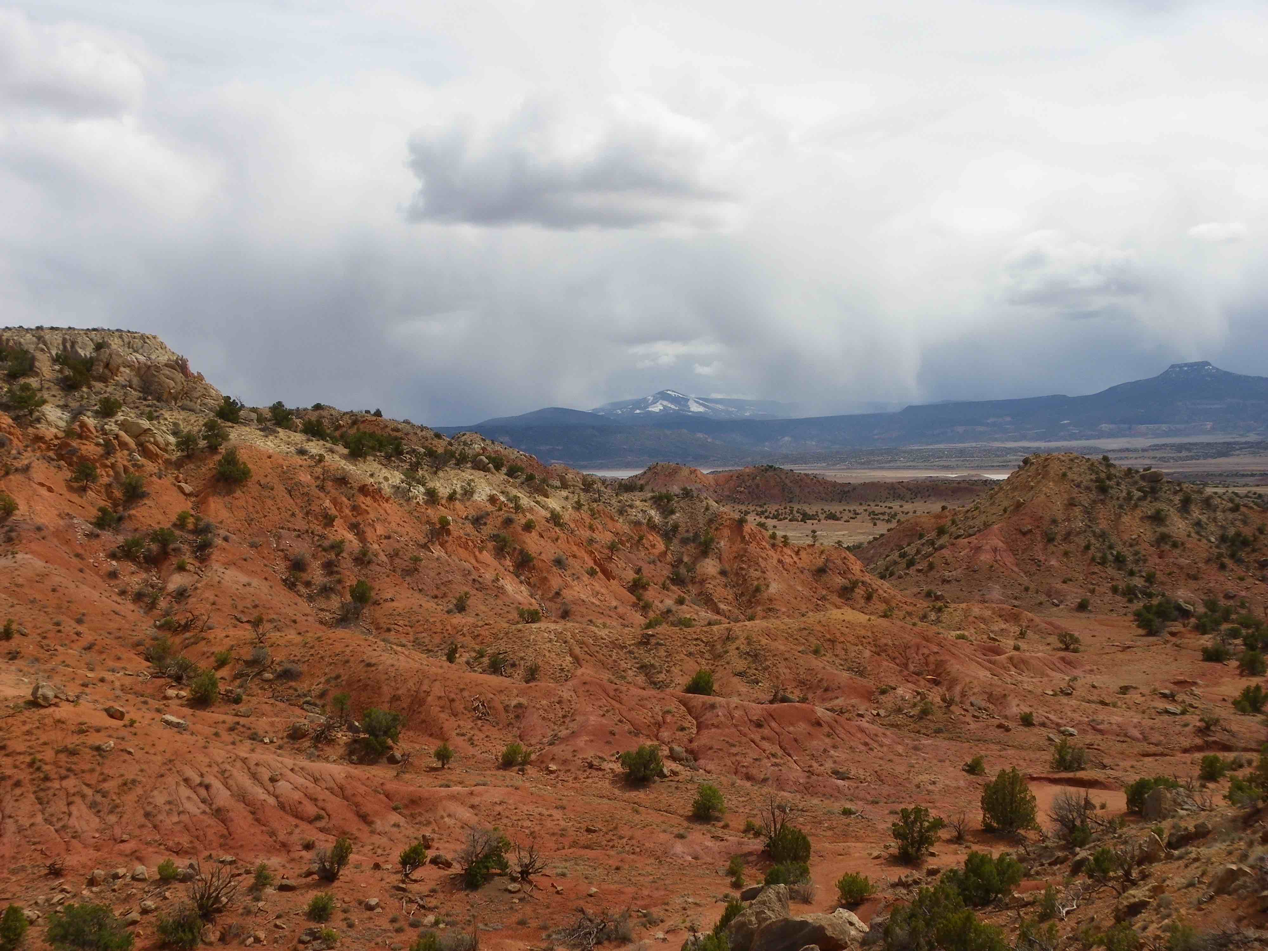

We gather to explore yet another mystery of our lives that we refer to as The Ground of Being. Ground implies something reliable, that we can feel supported by. Literally, the ground of livingness that has nourished us since conception, is the Earth. The fruits of the earth have formed us into Being. We are an expression of the nurturing and healing generosity of the earth’s vast love. This love is interwoven into the ground of our body-being, within the earth and throughout the cosmos as an evolutionary wisdom that creates and sustains life.

We will embark on a journey to discover and unveil The Ground of Being within our own bodies. And by doing so, we may connect with the evolving genius of life that guides us in every moment. By feeling into the universal peace of Life itself, we may tap into a power, that heals and restores balance by transforming those conditions in life that have separated us from The Ground of our own Being.

As a wazifah caravan of beloveds we will contemplate The Ground of Being through original wazifah inspired dances, meditation, breathing practices, embodiment processes, silence, being in nature and group sharing. During the Sesshin portion, silence will inform us and be a guide as we share wazifah dances and attune to nature around us.

Social Silence begins Monday morning and ends Wednesday at breakfast.

The Weekend Dance & Wazifah Immersion:
Starts on Thursday 5/7, with dinner at 6:00 pm and concludes with Sunday lunch 5/10.
Wazifah Sesshin:
Starts on Sunday 5/10 with dinner at 6pm and concludes with Wednesday lunch 5/13.
There will be social silence Monday morning thru Wednesday morning. There will be a sharing circle for retreatants to offer any insights, reflections or inspirations that arise during the Sesshin.

MEALS: ONLY VEGETARIAN FOOD WILL BE SERVED – AGAIN BY OUR COOK BREEZY

LODGING: 2 persons shared room/bring your own bedding: All bathrooms/showers are shared.
Campers are responsible to bring their own gear and can use showers in housing units.

The retreat fee covers only expenses, such as food and lodging for participants and staff, insurance, etc. All participants are invited to contribute Dana to honor the dedication of the retreat leaders for preparation, behind the scenes work and leading of the retreat. We suggest a range of $33-$101 per day/person. You are encouraged to feel into the value and inspiration that you receive from the retreat and what is within your means, which may be higher or lower than what’s suggested.

Thank you for offering your Dana in addition to the basic cost of the retreat.

Please write checks to Dances of Universal Peace Santa Fe
Mail with registration form to NurAlima Lin Reams, 4162 Midnight Owl, Santa Fe, NM 87507
Cancellation fee is $50.00. After 4/8/20, add $50 to Registration Fee. No refunds after 4/31/20
*Some work trade scholarships are available*
Questions: linreams@centurylink.net, 505-603-7394

*****Help us to make this a fragrance-free event!*****

The Ground of Being Registration Form – please print and then fill in/circle and mail with your check.

Name:__________________________________ Email: _______________________________________

Phone ____________________Address:____________________________________________________

Long weekend (Thursday dinner – Sunday lunch): Shared Room $300 /Camping $240 /Commuter $195
Sesshin (Sunday dinner – Wednesday lunch): Shared Room $300 / Camping $240 / Commuter $195
Optional Bedding Rental $10: Yes or No Total Payment: _________________

FOOD OPTIONS: Gluten Free / Dairy Free SEVERE FOOD ALLERGIES:____________________________

EMERGENCY CONTACT:__________________________________________________________________

ANYTHING ELSE YOU WOULD LIKE US TO KNOW:______________________________________________

